Task 1b – Designing Documents
Low Fidelity Mock ups:
Sign Up Page:
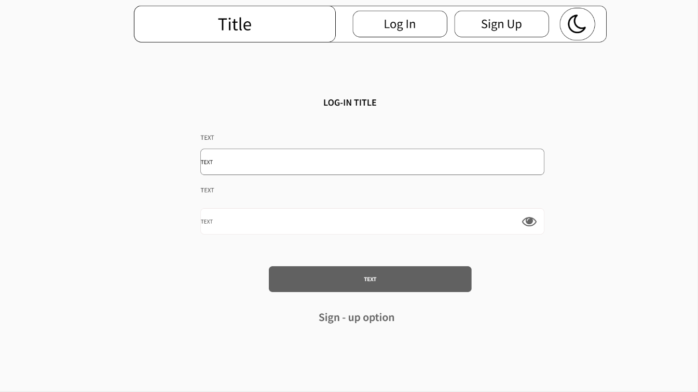
Login Page:
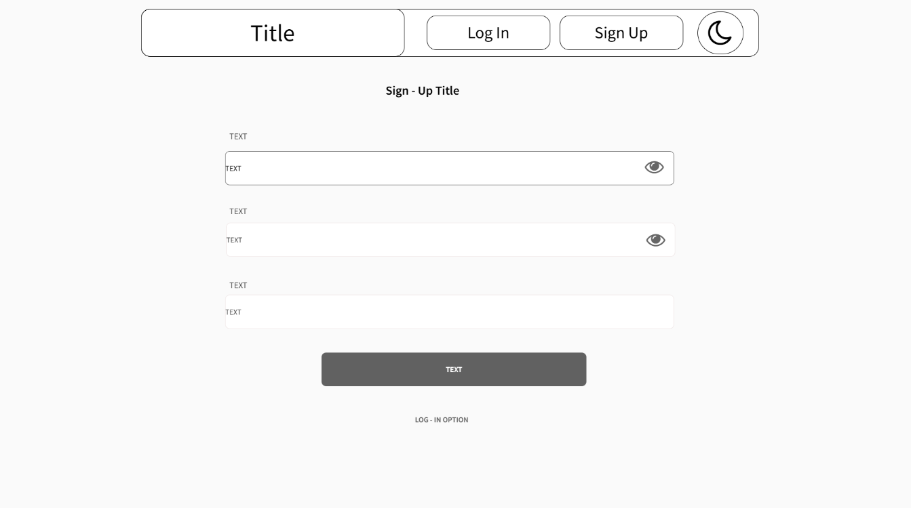

Home Page:
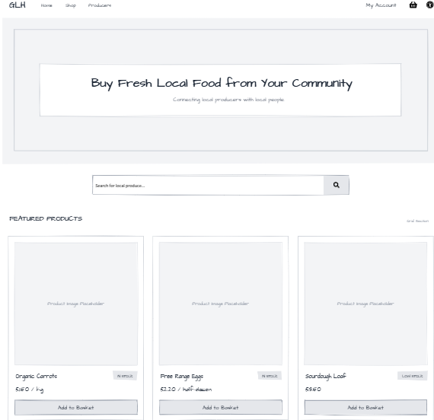
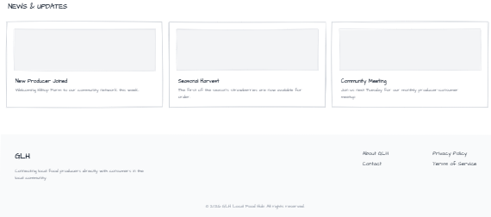
Product Categories:
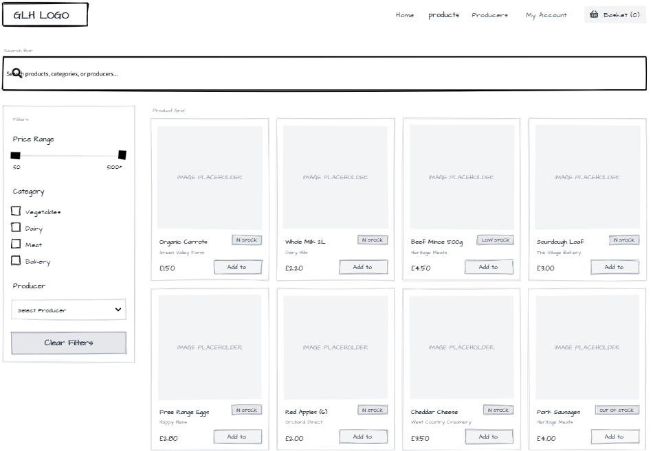

Product Detail Page:
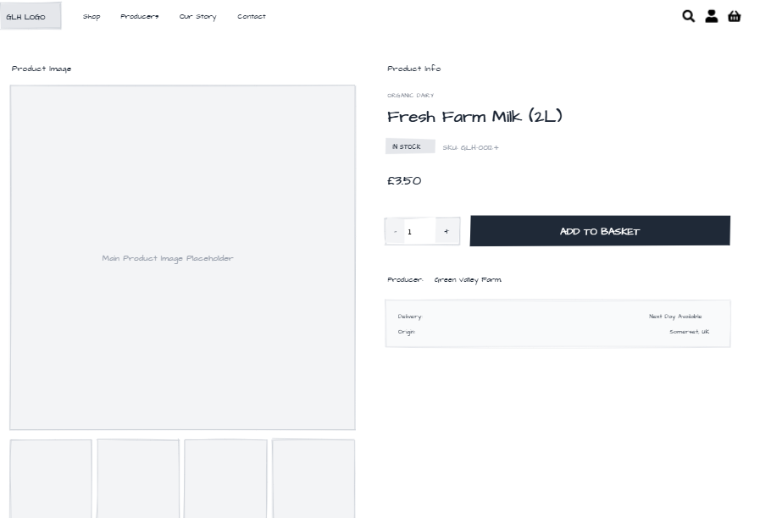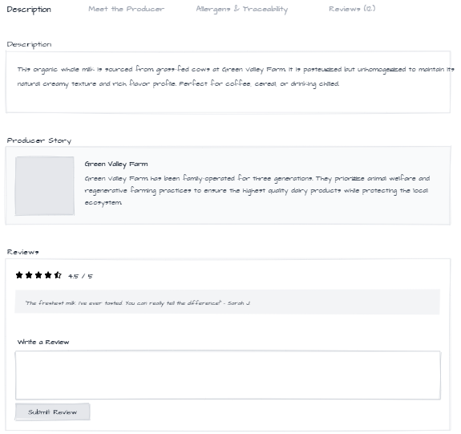
Visual/Interface Designs:
Home Page:
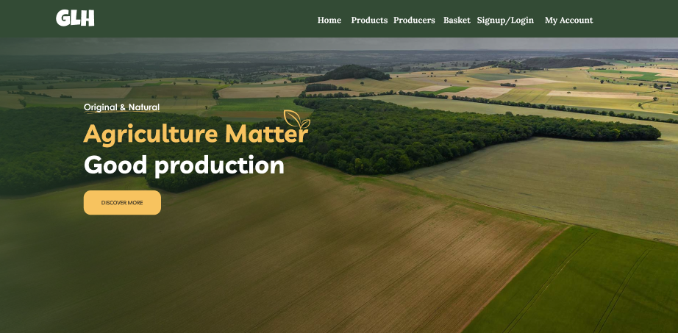Products Page:
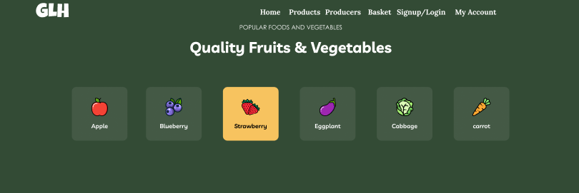

Producers:

Footers:
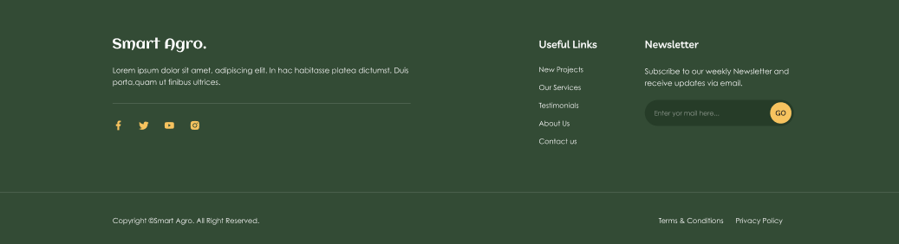
Login Page:
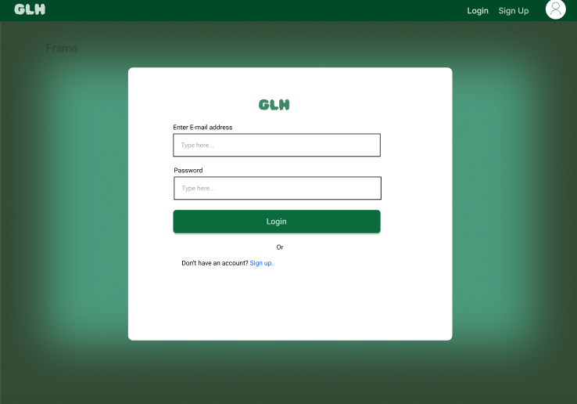

Sign Up Page:
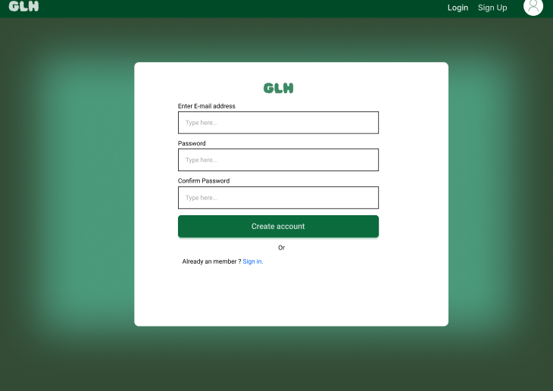
Algorithms Design
Flow Chart:
Pseudocode:
Customer Places Order with Stock Check + Loyalty Discount
FUNCTION placeOrder(customerID, basketItems, loyaltyPointsToUse, paymentDetails)
IF NOT isLoggedIn(customerID)
RETURN "Please log in first"
END IF
total = 0
FOR EACH item IN basketItems
stock = getStock(item.productID)
IF stock < item.quantity
RETURN "Not enough stock for " + item.name
END IF
total = total + (item.price * item.quantity)
END FOR
discount = 0
IF loyaltyPointsToUse > 0
pointsAvailable = getCustomerPoints(customerID)
IF loyaltyPointsToUse > pointsAvailable
RETURN "Not enough loyalty points"
END IF
discount = loyaltyPointsToUse * 0.05 // 1 point = 5p off
END IF
finalTotal = total - discount
IF processPayment(finalTotal, paymentDetails) == SUCCESS
FOR EACH item IN basketItems
reduceStock(item.productID, item.quantity)
END FOR
newPoints = floor(total / 10) // 1 point per £10
updatePoints(customerID, pointsAvailable - loyaltyPointsToUse + newPoints)
orderID = createOrder(customerID, basketItems, finalTotal)
sendConfirmationEmail(customerID, orderID)
RETURN "Order placed successfully"
ELSE
RETURN "Payment failed"
END IF
END FUNCTION
Producer updates Stock in real time:
FUNCTION updateStock(producerID, productID, newQuantity)
IF NOT isAuthorised(producerID, productID)
RETURN "No permission for this product"
END IF
IF newQuantity < 0
RETURN "Stock cannot be negative"
END IF
oldStock = getStock(productID)
saveStock(productID, newQuantity)
broadcastUpdateToCustomers(productID, newQuantity) // instant push to shop pages
IF newQuantity < 10 AND oldStock >= 10
sendLowStockEmail(producerID, productID, newQuantity)
END IF
RETURN "Stock updated successfully"
END FUNCTION
Customer Redeems Point at Checkout:
FUNCTION redeemLoyaltyAtCheckout(customerID, orderTotal, pointsToUse)
availablePoints = getCustomerPoints(customerID)
IF pointsToUse > availablePoints
RETURN "Not enough points", orderTotal
END IF
discount = pointsToUse * 0.05 // example: 1 point = 5p
newTotal = orderTotal - discount
RETURN discount, newTotal
END FUNCTION
// After payment success
FUNCTION updatePointsPostPurchase(customerID, pointsUsed, orderTotal)
earned = floor(orderTotal / 10) // 1 point per £10
current = getCustomerPoints(customerID)
updated = current - pointsUsed + earned
saveCustomerPoints(customerID, updated)
END FUNCTION
Customer Tracks Order Status:
FUNCTION trackOrderStatus(customerID, orderID)
IF NOT isLoggedIn(customerID)
RETURN "Log in required"
END IF
order = getOrder(orderID)
IF order.customerID != customerID
RETURN "Not your order"
END IF
currentStatus = order.status
lastViewed = getLastViewedStatus(customerID, orderID)
IF currentStatus != lastViewed
sendNotification(customerID, orderID, currentStatus)
saveLastViewedStatus(customerID, orderID, currentStatus)
END IF
RETURN {
currentStatus: currentStatus,
history: order.statusHistory,
estimatedTime: order.estimatedReadyTime
}
END FUNCTION
GLH approves New Product:
FUNCTION submitNewProduct(producerID, name, price, description, photo)
IF NOT isAuthorised(producerID)
RETURN "Not authorised"
END IF

product = {
producerID: producerID,
name: name,
price: price,
description: description,
photo: photo,
status: "Pending"
}
saveProduct(product)
notifyAdminNewProduct(product.id)

RETURN "Submitted for approval"
END FUNCTION
FUNCTION approveProduct(adminID, productID, approve)
IF NOT isAdmin(adminID)
RETURN "Not authorised"
END IF
product = getProduct(productID)
IF product.status != "Pending"
RETURN "Already processed"
END IF
IF approve == true
product.status = "Live"
saveProduct(product)
sendApprovalEmail(product.producerID)
ELSE
product.status = "Rejected"
saveProduct(product)
sendRejectionEmail(product.producerID, reason)
END IF
RETURN "Product " + (approve ? "approved" : "rejected")
END FUNCTION
Data Dictionary:
Table Name | Field Name | Data Type | Size / Format | Description | Constraints / Rules
Customers | customerID | INTEGER | Auto-increment | Unique number for each customer | Primary Key, Auto-increment
Customers | name | VARCHAR | 100 | Full name of the customer | Not null
Customers | email | VARCHAR | 150 | Customer's email address (used for login) | Unique, Not null
Customers | password_hash | VARCHAR | 255 | Secure hashed version of the password | Not null
Customers | address | TEXT | - | Delivery address (house number, street, town, postcode) | -
Customers | phone | VARCHAR | 20 | Contact phone number | -
Customers | created_date | DATE | YYYY-MM-DD | Date the account was created | Not null, default current date
Products | productID | INTEGER | Auto-increment | Unique number for each product | Primary Key, Auto-increment
Products | name | VARCHAR | 150 | Name of the product (e.g. "Organic Carrots") | Not null
Products | price | DECIMAL | 10,2 | Price in pounds (e.g. 2.99) | Not null, >= 0
Products | stock | INTEGER | - | Current number of items in stock | Not null, >= 0
Products | producerID | INTEGER | - | Links to the producer who supplies this item | Foreign Key to Producers.producerID
Products | description | TEXT | - | Full details about the product (how grown, size, etc.) | -
Products | image_url | VARCHAR | 255 | Web link to the product photo | -
Products | category | VARCHAR | 50 | Type of product (e.g. Vegetables, Dairy, Meat, Bakery) | -
Products | harvest_date | DATE | YYYY-MM-DD | Date the item was harvested or made (for freshness) | -
Products | status | ENUM | 'active', 'pending', 'inactive' | Shows if product is live on shop or waiting for approval | Default 'pending'
Producers | producerID | INTEGER | Auto-increment | Unique number for each producer/farmer | Primary Key, Auto-increment
Producers | name | VARCHAR | 100 | Name of the producer or farm | Not null
Producers | email | VARCHAR | 150 | Producer's contact email | Unique, Not null
Producers | farm_description | TEXT | - | Short story about the farm and how they grow/make food | -
Producers | methods | TEXT | - | Growing methods (e.g. organic, free-range, no chemicals) | -
Producers | approved | BOOLEAN | - | Whether GLH staff has approved this producer | Default FALSE
Orders | orderID | INTEGER | Auto-increment | Unique number for each order | Primary Key, Auto-increment
Orders | customerID | INTEGER | - | Links to the customer who placed the order | Foreign Key to Customers.customerID
Orders | order_date | DATE | YYYY-MM-DD | Date the order was placed | Not null
Orders | order_time | TIME | HH:MM:SS | Time the order was placed | Not null
Orders | type | ENUM | 'collection', 'delivery' | Whether customer collects or gets delivery | Not null
Orders | delivery_time | DATETIME | YYYY-MM-DD HH:MM | Chosen collection or delivery time slot | -
Orders | total_amount | DECIMAL | 10,2 | Final amount paid (after discount) | Not null, >= 0
Orders | status | VARCHAR | 50 | Current order status (Received, Preparing, Ready, Collected, Delivered) | Not null
Order_Items | orderItemID | INTEGER | Auto-increment | Unique number for each item in an order | Primary Key, Auto-increment
Order_Items | orderID | INTEGER | - | Links to the main order | Foreign Key to Orders.orderID
Order_Items | productID | INTEGER | - | Links to the product bought | Foreign Key to Products.productID
Order_Items | quantity | INTEGER | - | Number of this product ordered | Not null, > 0
Loyalty | loyaltyID | INTEGER | Auto-increment | Unique record for loyalty points | Primary Key, Auto-increment
Loyalty | customerID | INTEGER | - | Links to the customer | Foreign Key to Customers.customerID
Loyalty | points_balance | INTEGER | - | Current number of loyalty points | Not null, >= 0
Loyalty | last_updated | DATETIME | YYYY-MM-DD HH:MM:SS | When the points were last changed | -

Test Strategy:
Date of test | Component to be tested | Type of test to be carried out | Prerequisites and dependencies
23 March 2026 | Home page (navigation bar, footer, hero section, featured products grid, search bar) | Acceptance testing | Basic website layout and static pages created. Navigation bar and footer already built.
23 March 2026 | Product catalogue/shop page (search bar, filters, product grid, pagination) | Acceptance testing | Home page complete. Some test products added to database.
24 March 2026 | Single product detail page (image, price, stock, description, producer info, add to basket) | Acceptance testing | Shop page working. At least one product in database.
24 March 2026 | Basket page (item list, quantity adjust, remove, total, proceed button) | Acceptance testing | Product detail page complete. Add to basket function working.
25 March 2026 | Checkout page (delivery/collection choice, time slot picker, loyalty discount, payment) | Acceptance testing | Basket page complete. Test payment gateway in safe mode ready.
25 March 2026 | Order confirmation and tracking page (status timeline, confirmation email) | Acceptance testing | Checkout complete. Test orders saved in database.
13 April 2026 | Register page (form fields, validation, error messages, account creation) | Unit + Integration testing | Database ready. Email service test mode ready.
13 April 2026 | Login page (authentication, error messages, forgot password link) | Unit + Integration testing | Register page tested. Test accounts created in database.
14 April 2026 | My Account page (edit details, view order history, see loyalty points balance) | Acceptance testing | Login working. Test customer account created.
14 April 2026 | Producer dashboard (update stock, edit products, view orders, low-stock alerts) | Acceptance testing | Producer test account ready. Products in database.
15 April 2026 | Loyalty scheme (earn points on order, view balance, apply discount at checkout) | Integration testing | Checkout and order system complete. Loyalty rules tested.
15 April 2026 | Accessibility panel (larger text, high contrast, screen reader mode, save settings) | Accessibility testing | All main pages built. Screen reader software ready for checking.
16 April 2026 | Admin area (approve new producers, view sales reports, update site news/offers) | Acceptance testing | Admin test account ready. Producers and orders in database.
16 April 2026 | Full customer order flow (browse → add to basket → checkout → track order) | System testing | All customer pages and database ready. Test payment in safe mode.

